# Problem Set 3

With the first given we can see how the visual magnitude of the binary system fluctuates as time changes.

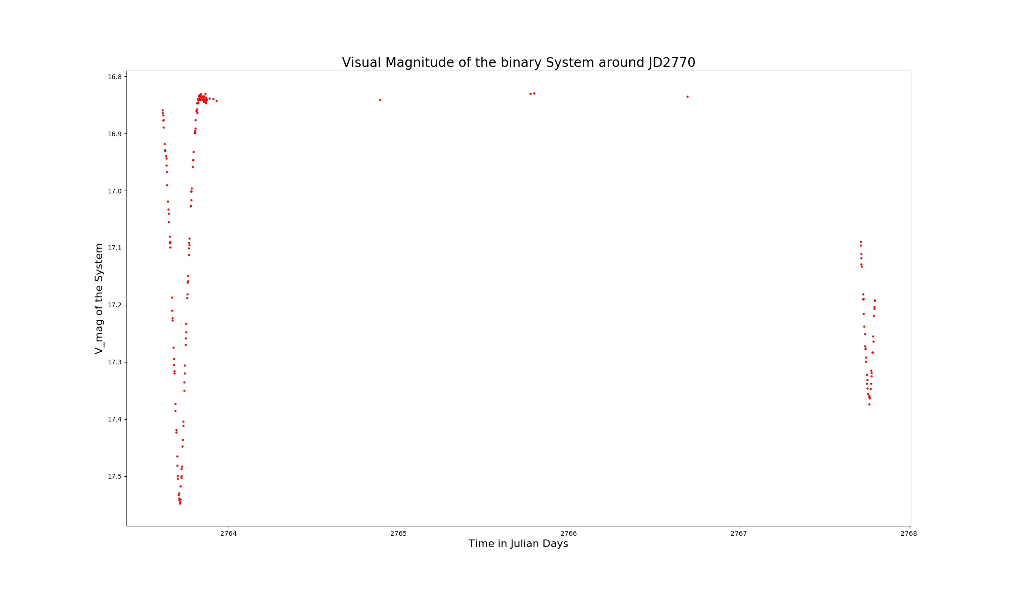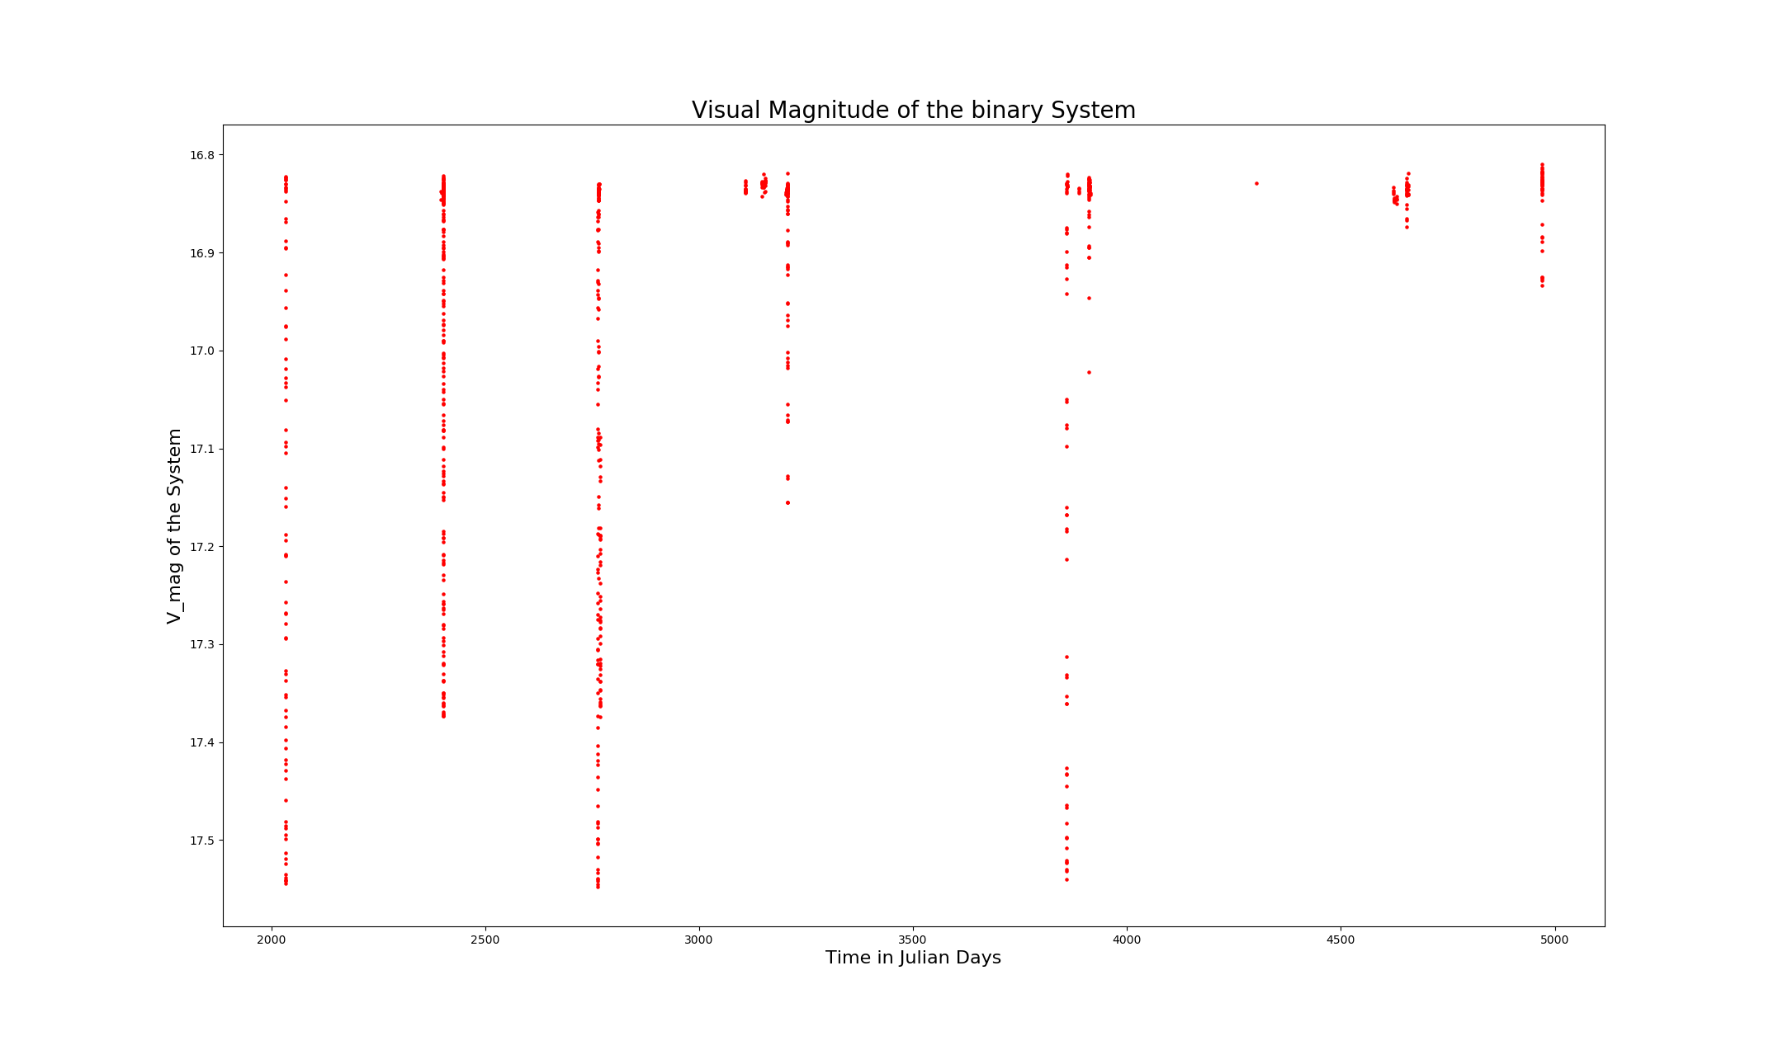The data shows that the magnitude drops during certain interval of times, indicating the planets transit past each other (observed at least). Looking at the magnitude near JD2770 We can have a better idea of the period.

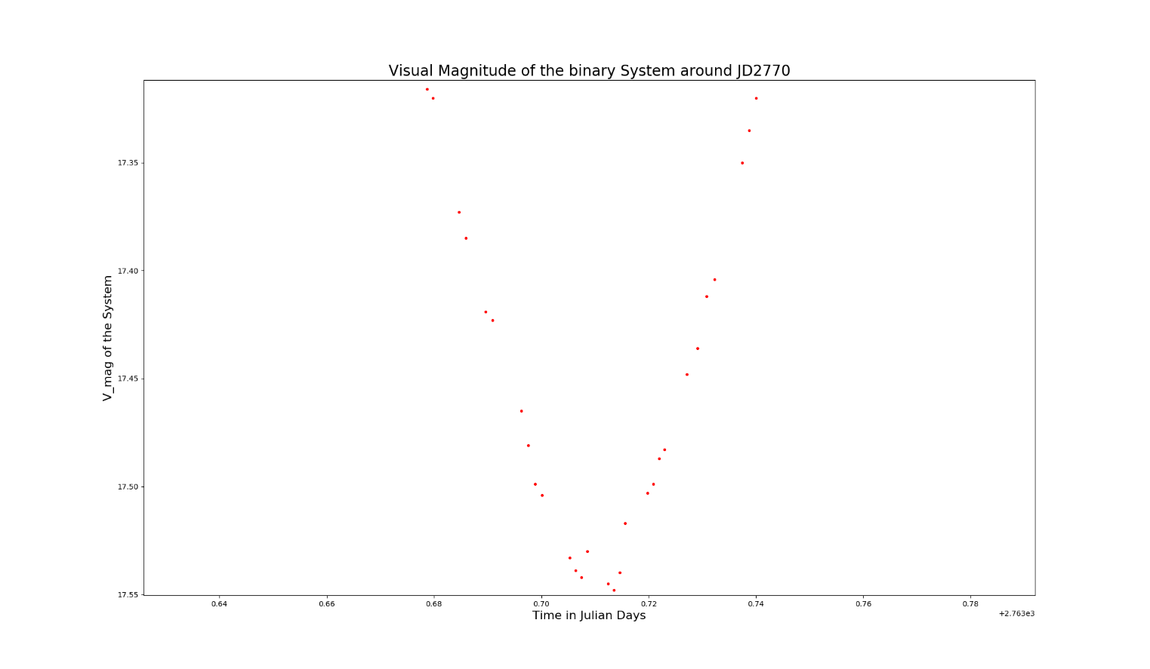With two clear Minima’s with the graph, the must indicate when the primary star transits the secondary star and vice versa. Thus, by locating the difference in time between the two minimas, we can identify half the period.

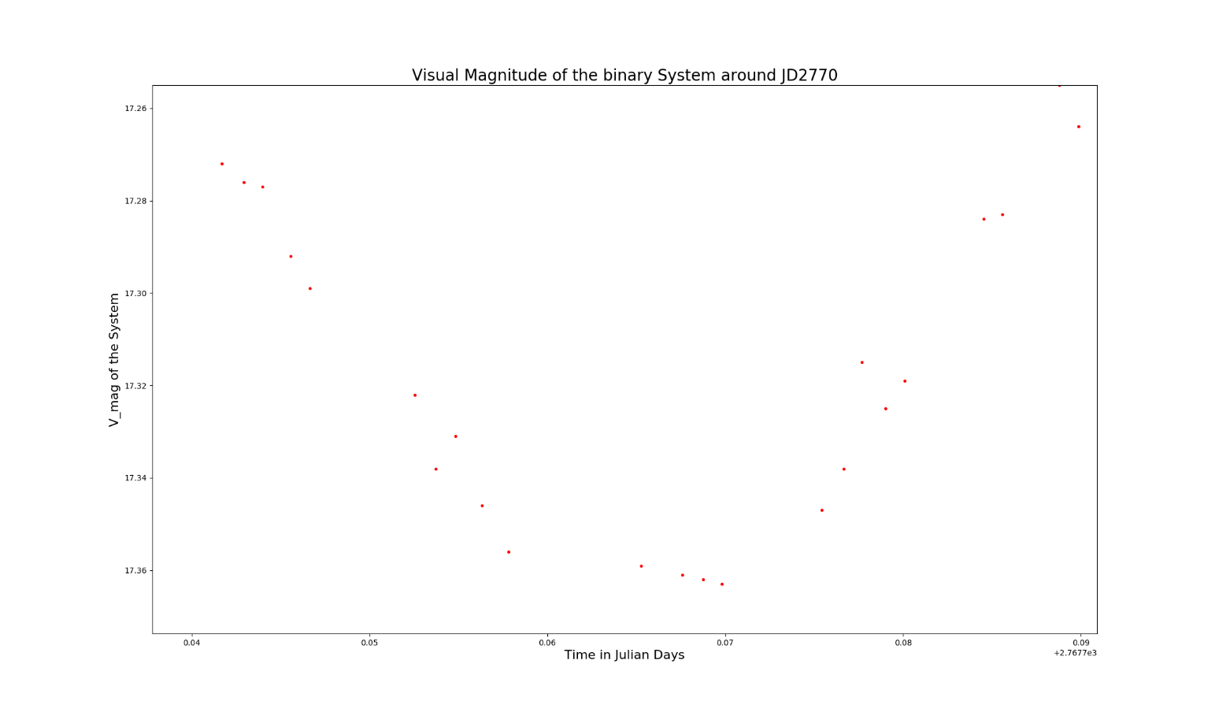Looking at the first minima, we can’t just take the maximum magnitude (lowest brightness) to be the point of the first transit. As the maximum magnitude does not take place at the tip of the curvature of the parabola. This is because due to the error in the data collection the magnitude of some points may waver from the actual value. Thus we can approximate the time of the first transit to take place at the centre of the parabola (the dip). Which in this case was at 2763.71025 JD.

For the second minima the centre of parabola (the dip) takes place at 2767.7659 JD.

Thus,

$$P=2*\left(2767.7659- 2763.71025\right) Days$$

$$P=8.1113 Days or 700816.32 Seconds$$

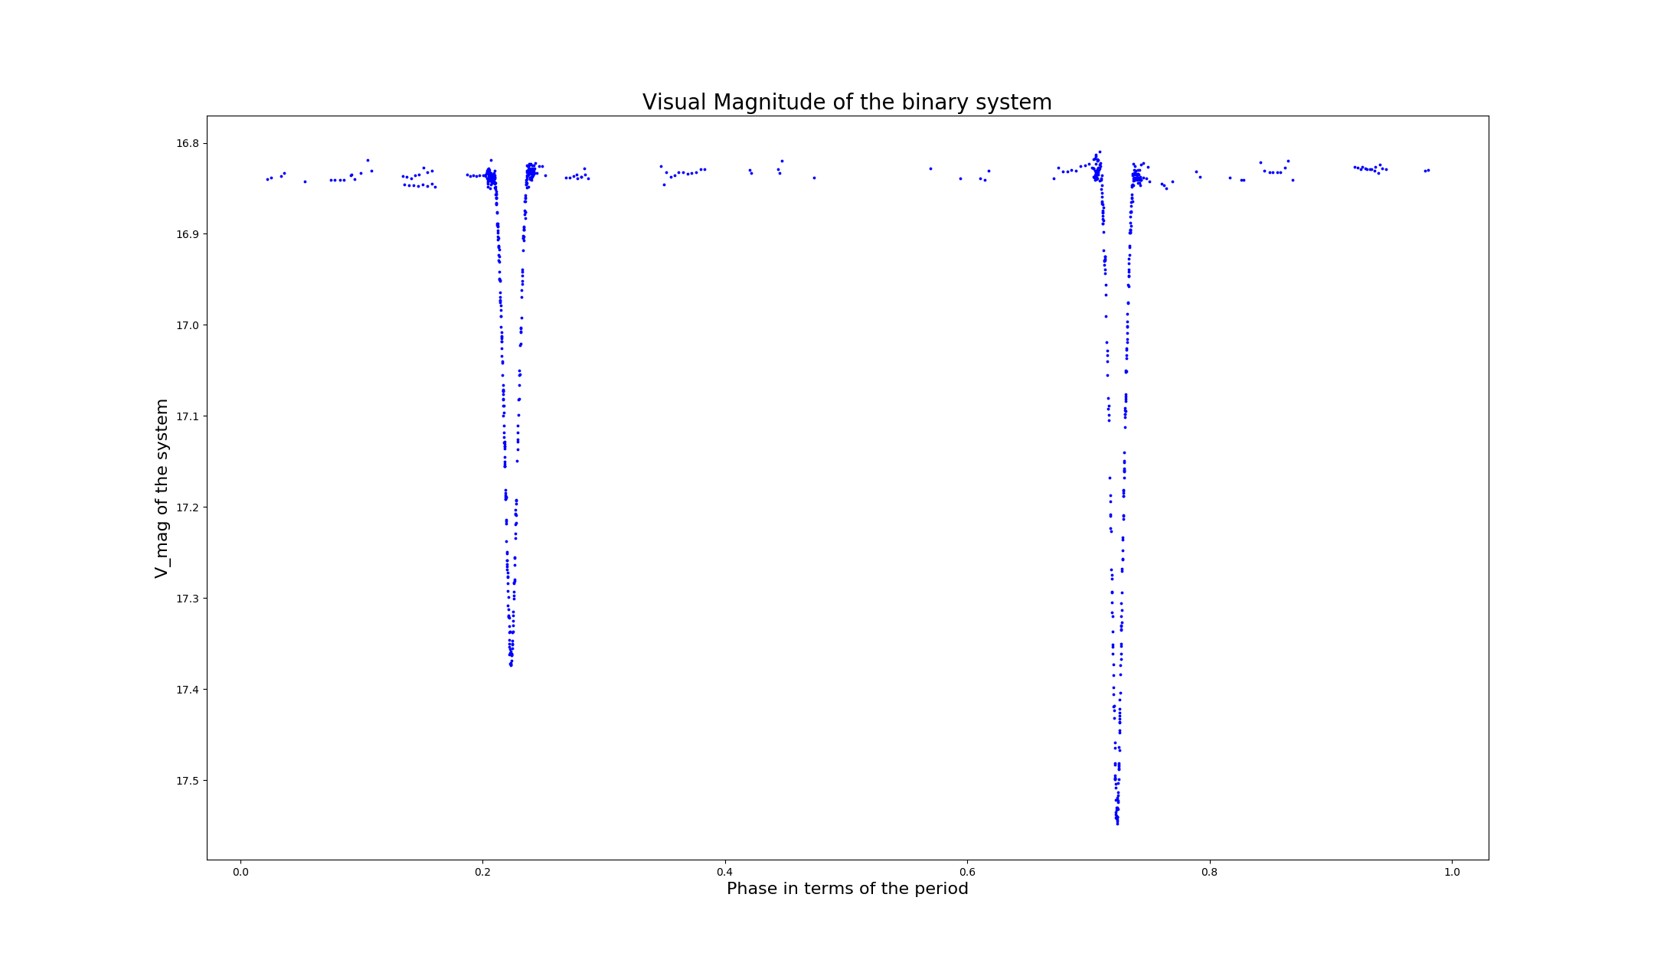The time at which the dips were taken were adjusted to ensure that the Data set was perfectly phased and in turn, clearly indicated the drop and rise in visual magnitude of this binary system in one period of time.

The perfect overlay is an indication of the credibility for the period.

Using the second data set, we can find the radial velocities of the Stars and the system. By using a curve fit for both the stars, we can use python to indicate the amplitude of the curves (which indicated the individual radial velocities) and the y-offset of the curves (which indicated the centre of mass velocity of the system).

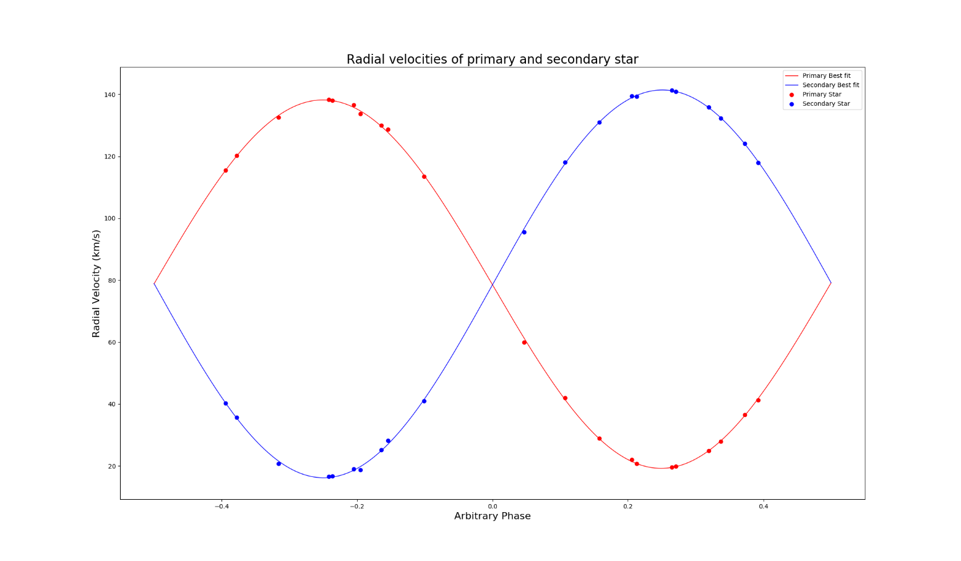 $For the radial velocity of primary star, V_{rp}=V_{p}sini=59.47 kms^{-1}$

$$For the radial velocity of secondary star, V_{sp}=V_{s}sini=62.59 kms^{-1}$$

$$For the centre of mass, the velocity, V_{COM}=78.81 kms^{-1}$$

Due to the fact that the motion of the stars are so similar and they cover simlar course of motion when eclipsing, it is safe to assume, these stars follow circular orbits. A circular shape. Thus,

$$V_{r}=\frac{2πa}{P}$$

Where a is the semi-major axis of the sun to the cente of mass

$$a=\frac{PV_{r}}{2π}$$

$$For the primary star, a_{p}=6.633*{10}^{6} Km$$

$$For the secondary star, a_{s}=6.982*{10}^{6} Km$$

$$The total Semi-major axis, a_{tot}=1.361*{10}^{7} Km$$

Knowing that $m_{p}a_{p}=m_{s}a_{s}$

We can state that $\frac{a_{p}}{a_{s}}=\frac{m_{s}}{m_{p} }=1.05253575698$, where $m_{total}=m_{p}+m_{s}$

Knowing Kepler’s third law for an inclination i:

$$P^{2}=\frac{4π^{2}}{Gm_{total}}a_{tot}^{3}\sin^{3}{i}$$

Assuming i = 90 degrees

$$m_{total}=\frac{4π^{2}a_{tot}^{3}}{GP^{2}}$$

Maximum mass for the total

$$m_{total}=m_{p}\left(1+\frac{m_{s}}{m_{p}}\right)$$

$$\frac{m_{total}}{1+\frac{m_{s}}{m_{p}}}=m_{p}$$

$$m_{S}=m_{total}-m_{p}$$

Since the ratio is known between the masses is known, both the primary and secondary star’s mass can be known

$$mass of the primary star is 1.56*{10}^{30} kg or 0.7841 Solar masses$$

$$mass of the secondary star is 1.48*{10}^{30} kg or 0.7449 Solar masses$$

Assuming the transit is viewed head on, i.e. the incinlination I is 90 degrees, we can use the visual magnitude graph to determine the radius of the stars being transitted and transitting. This is done by understading the time at which the dip and rise of the brigthness of binary system occurs.

$$T_{1}$$

Let the time T1 be at which the transitting star, the red star, is just about eclipse the blue star, at this point the visual magnitude is at maximum brightness but from this point the overall brightness of the system will decrease.

$$T_{2}$$

Let T2 be the point at which the transiting star, the red one, is eclipsing the blue star. At this point the overall brightness of the system is at the lowest, but after this the brightness can only increase as it will begin to cover less area of the blue star. The distance the red star covered from T1 to T2 is the total diameter of the blue star. Knowing how long this process took as well as the radial velocity of the red star, will allow us to determine the distance between T1 and T2.

$$T_{3}$$

Let T3 be the point at which the transiting star, the red star, just fully ended eclipsing the blue star. At this point the brightness of the system will be back to the maximum and constant until the next eclipse. Thus using, this knowledge of the three times we can see how it corresponds to one of the dips seen in the phased out visual magnitude curve.

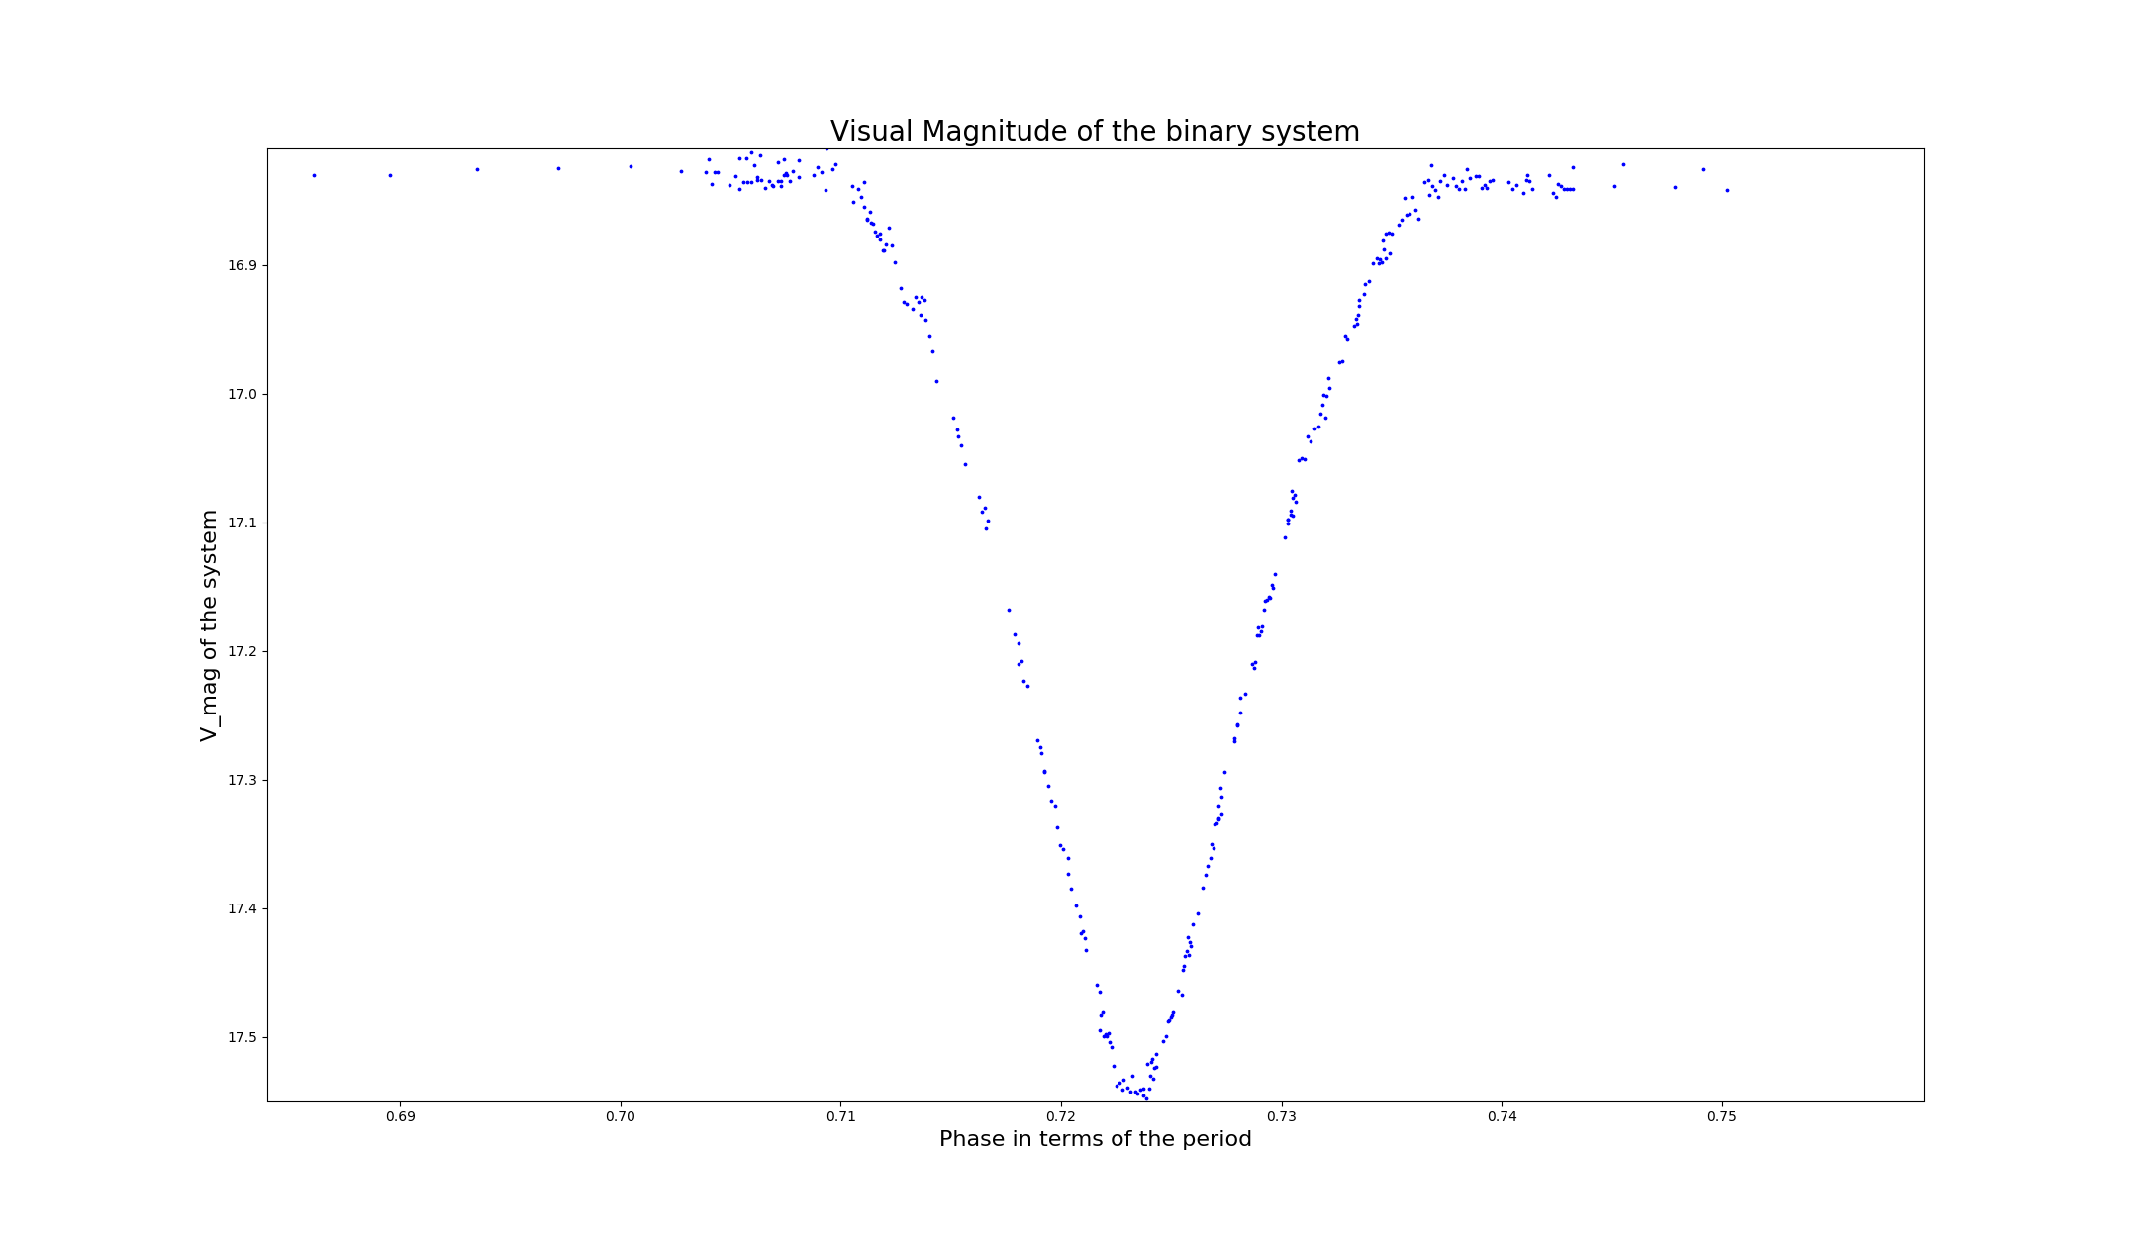

$$T_{1}$$

$$T_{3}$$

$$T_{2}$$

Using python, the best approximations for all three times can be made. Without knowing the specific spectrometry of the individual stars, we have to assume the star with the lower radius, is the star with the lower mass.

Since the velocity of the stars are relative of each other, the total velocity will be used to calculate their individual radii.

$v_{rt}=v_{rp}+v_{rs}$

$$The radius of the primary star, r_{p}=\frac{v_{rt}\left(T_{3}-T_{2}\right)}{2}=5.69*{10}^{5} km or 0.818 Solar Radii$$

$$The radius of the secondary star, r_{s}=\frac{v_{rt}\left(T_{2}-T_{1}\right)}{2}=5.87*{10}^{5} km or 0.844 Solar Radii$$

The accuracy of these values was cross-checked by doing the same calculation with the other dip in the period. The values agree.